System Trading Strategy Performance
This report presents a trade-by-trade quantitative review of the NIFTY intraday execution strategy, traded on the 5-minute chart, for the 12-month period from September 2025 to August 2026. All 189 logged trades in this window are included. Every trade is executed with 6 lots (390 quantity at 65 per lot): 3 lots are exited at Target 1, fixed at 27 points, and the remaining 3 lots at Target 2 (60 or 70 points, as recorded). Profit and loss is measured in NIFTY spot-chart points and evaluated against an assumed capital base of ₹1,00,000.
12-MONTH NET P&L  ₹7,69,860  Before transaction costs | RETURN ON CAPITAL BASE  769.86%  On assumed ₹1,00,000 base | PROFIT FACTOR  1.93  Gross profit ÷ gross loss
MAXIMUM DRAWDOWN  ₹68,055  3 Jun – 17 Jun 2026 | WIN RATE (EXCL. BE)  55.17%  80 targets / 145 decisive trades | MONTHLY CONSISTENCY  12 / 12 Months  Profitable months

Capital Efficiency
Against the assumed capital base of ₹1,00,000, the strategy generated a net trading profit of ₹7,69,860 across 189 trades on 180 trading days — a return of 769.86%, or 7.70× the base capital. All 12 months closed positive. All figures are before brokerage, statutory charges and slippage; their effect is quantified in the Transaction Cost Sensitivity section.

Core Quantitative Highlights
PERFORMANCE | VALUE | INTERPRETATION
Total trades | 189 trades (180 days) | Complete log for Sep 2025 – Aug 2026
Gross profit vs. gross loss | ₹16,00,560 / –₹8,30,700 | Profit factor of 1.93
Average target vs. average SL | ₹17,111 / –₹12,780 | Payoff ratio of 1.34 : 1
Expectancy per trade | ₹4,073 (10.44 pts) | Average net result on 390 quantity
Breakeven win rate required | 42.75% | Versus achieved 55.17% (excl. BE)

Strategy Framework
Every position is split into two equal legs of 3 lots (195 quantity each). Leg 1 is booked at Target 1, fixed at 27 points. Leg 2 is held for Target 2; once Target 1 is booked, the stop on Leg 2 moves to the entry price. Each trade therefore resolves into one of three outcomes:
OUTCOME | LEG 1: 3 LOTS | LEG 2: 3 LOTS | RESULT FOR THE TRADE
Target | Booked at Target 1 (+27 pts) | Booked at Target 2 | Full profit on both legs
Breakeven (BE) | Booked at Target 1 (+27 pts) | Exited at entry price | Profit of ₹5,265 from Leg 1
Stop-loss (SL) | Stopped out | Stopped out | Loss on the full 390 quantity

Calculation Basis
• Scope: all 189 trades dated 1 September 2025 to 31 August 2026.
• P&L: point distance on the NIFTY spot chart × quantity. Target = 27 pts × 195 + Target 2 pts × 195; BE = 27 pts × 195; SL = stop distance × 390.
• Sequencing: trades are ordered by date and entry time for the equity curve, drawdown and streak calculations.
• Definitions: profit factor = gross profit (Target + BE) ÷ gross loss (SL); win rate (excl. BE) = Target ÷ (Target + SL); drawdown is measured on cumulative P&L after each trade.
• Costs & capital: results exclude brokerage, taxes and slippage (see Transaction Cost Sensitivity); the ₹1,00,000 capital base is an assumption used for return ratios.

Performance Overview

Core Quantitative Highlights
MEASURE | VALUE | INTERPRETATION
Total trades | 189 | 180 trading days; 80 Target · 65 SL · 44 BE
Gross profit | ₹16,00,560 | Target and BE trades combined
Gross loss | –₹8,30,700 | SL trades
Net P&L | ₹7,69,860 | 769.86% of assumed capital base
Profit factor | 1.93 | Gross profit earned per ₹1 of gross loss
Average Target / average SL | ₹17,111 / –₹12,780 | Payoff ratio of 1.34 : 1
Expectancy per trade | ₹4,073 | Equivalent to 10.44 NIFTY points on 390 quantity
Breakeven win rate required | 42.75% | Achieved: 55.17% (excl. BE)

Outcome Distribution
OUTCOME | TRADES | % OF TRADES | AVERAGE P&L | TOTAL P&L
Target | 80 | 42.33% | ₹17,111 | ₹13,68,900
Breakeven (BE) | 44 | 23.28% | ₹5,265 | ₹2,31,660
Stop-loss (SL) | 65 | 34.39% | –₹12,780 | –₹8,30,700
Total | 189 | 100.00% | ₹4,073 | ₹7,69,860
Win rate methodology: Excluding breakeven trades, the win rate is 55.17% (80 Target / 145 decisive trades). Counting BE trades, each of which books Target 1, as positive outcomes, 65.61% of all trades (124 / 189) closed in profit.
Contribution of Target 1: The fixed 27-point partial exit converts every BE trade into a ₹5,265 gain. Across 44 BE trades this added ₹2,31,660, equal to 30.09% of total net P&L.

Equity Curve & Drawdown Analysis
Cumulative P&L is tracked after every trade. The curve’s lowest point was –₹15,990 on 15 Sep 2025 (trade 9); it turned positive on the next trade and did not fall below zero again. Each of the five deepest drawdowns was recovered to a new equity high within 17 trades of its prior peak.
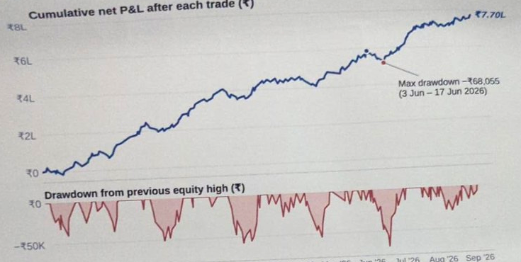
Figure 1. Cumulative net P&L (top) and drawdown from the running equity high (bottom). Reproduced from the supplied photograph; individual trade-level values were not provided.

Maximum Drawdown Profile
RISK PARAMETER | RECORDED METRIC | EVALUATION
Maximum drawdown | ₹68,055 | Largest fall in cumulative P&L from a prior high
Peak equity | ₹5,85,000 · 3 Jun 2026 | Trade 134: start of the drawdown
Trough equity | ₹5,16,945 · 17 Jun 2026 | Trade 143: lowest point before recovery
New equity high | 30 Jun 2026 | 17 trades / 27 calendar days after the peak
Recovery factor | 11.31× | Net P&L ÷ maximum drawdown
Drawdown vs. capital | 68.06% of ₹1,00,000 | 9.94% of the peak account value (₹6,85,000)

Anatomy of the June 2026 Drawdown
The drawdown comprised 9 consecutive trades without a Target: 6 SL (–₹83,850) and 3 BE (₹15,795), a net decline of ₹68,055. The sequence reflects a cluster of stop-losses rather than any single outsized loss.
TRADE | DATE | STRATEGY | OUTCOME | P&L | CUMULATIVE P&L
135 | 04 Jun 2026 | IRF | SL | –₹15,600 | ₹5,69,400
136 | 05 Jun 2026 | PDR | BE | ₹5,265 | ₹5,74,665
137 | 08 Jun 2026 | IRF | SL | –₹15,600 | ₹5,59,065
138 | 10 Jun 2026 | ORB | BE | ₹5,265 | ₹5,64,330
139 | 11 Jun 2026 | IRF | SL | –₹15,600 | ₹5,48,730
140 | 12 Jun 2026 | ORB | SL | –₹11,700 | ₹5,37,030
141 | 12 Jun 2026 | PDR | BE | ₹5,265 | ₹5,42,295
142 | 16 Jun 2026 | ORB | SL | –₹11,700 | ₹5,30,595
143 | 17 Jun 2026 | IRF | SL | –₹13,650 | ₹5,16,945
 | Net |  | 6 SL · 3 BE | –₹68,055

Five Deepest Drawdowns
RANK | PEAK | TROUGH | DEPTH | NEW HIGH | TRADES TO RECOVER
1 | 3 Jun 2026 | 17 Jun 2026 | –₹68,055 | 30 Jun 2026 | 17
2 | 30 Jan 2026 | 11 Feb 2026 | –₹57,135 | 25 Feb 2026 | 14
3 | 6 Apr 2026 | 20 Apr 2026 | –₹53,820 | 28 Apr 2026 | 11
4 | 25 Nov 2025 | 5 Dec 2025 | –₹50,700 | 23 Dec 2025 | 14
5 | 2 Sep 2025 | 15 Sep 2025 | –₹40,170 | 24 Sep 2025 | 11

Monthly Performance
All 12 months between September 2025 and August 2026 closed with a profit. The average month returned ₹64,155 (median ₹58,890); the strongest was July 2026 at ₹1,38,060 and the weakest February 2026 at ₹2,535.
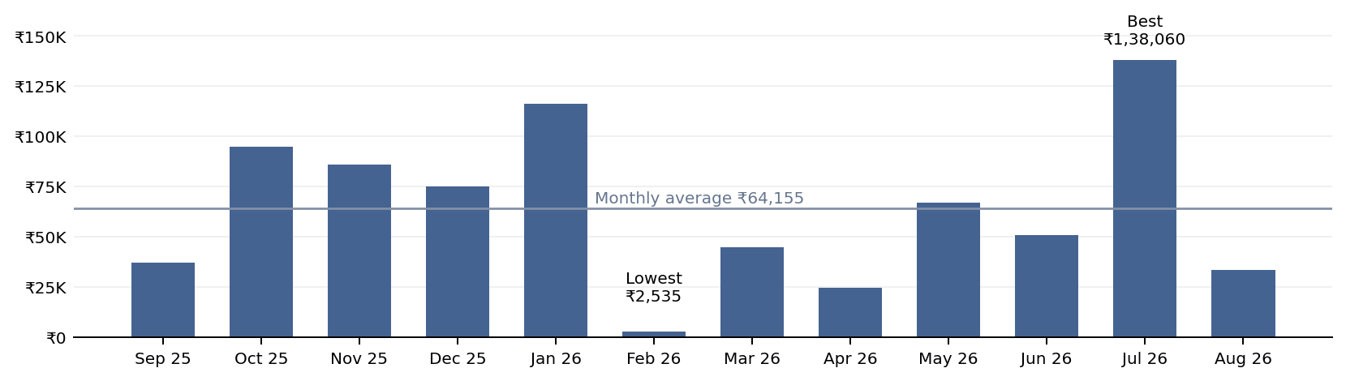
Figure 2. Net P&L by month, recreated from the monthly figures in the report.

Monthly Performance — Detailed Results
MONTH | TRADES | TARGET | SL | BE | WIN RATE  (EXCL. BE) | NET P&L | CUMULATIVE P&L
Sep 2025 | 16 | 5 | 6 | 5 | 45.45% | ₹37,050 | ₹37,050
Oct 2025 | 16 | 8 | 5 | 3 | 61.54% | ₹94,965 | ₹132,015
Nov 2025 | 13 | 6 | 3 | 4 | 66.67% | ₹85,800 | ₹217,815
Dec 2025 | 17 | 6 | 5 | 6 | 54.55% | ₹74,880 | ₹292,695
Jan 2026 | 12 | 6 | 1 | 5 | 85.71% | ₹116,415 | ₹409,110
Feb 2026 | 16 | 5 | 7 | 4 | 41.67% | ₹2,535 | ₹411,645
Mar 2026 | 13 | 7 | 6 | 0 | 53.85% | ₹44,655 | ₹456,300
Apr 2026 | 14 | 5 | 6 | 3 | 45.45% | ₹24,570 | ₹480,870
May 2026 | 13 | 6 | 4 | 3 | 60.00% | ₹66,885 | ₹547,755
Jun 2026 | 21 | 8 | 8 | 5 | 50.00% | ₹50,895 | ₹598,650
Jul 2026 | 20 | 12 | 6 | 2 | 66.67% | ₹138,060 | ₹736,710
Aug 2026 | 18 | 6 | 8 | 4 | 42.86% | ₹33,150 | ₹769,860
Total | 189 | 80 | 65 | 44 | 55.17% | ₹7,69,860 | ₹7,69,860
Average ₹64,155 · Median ₹58,890 · Standard deviation ₹39,714 · Best Jul 2026 · Weakest Feb 2026

Strategy-wise Performance
Each strategy is evaluated independently. IRF was the largest contributor to net P&L and ORB the most frequently traded; together they generated 74.75% of total profit.
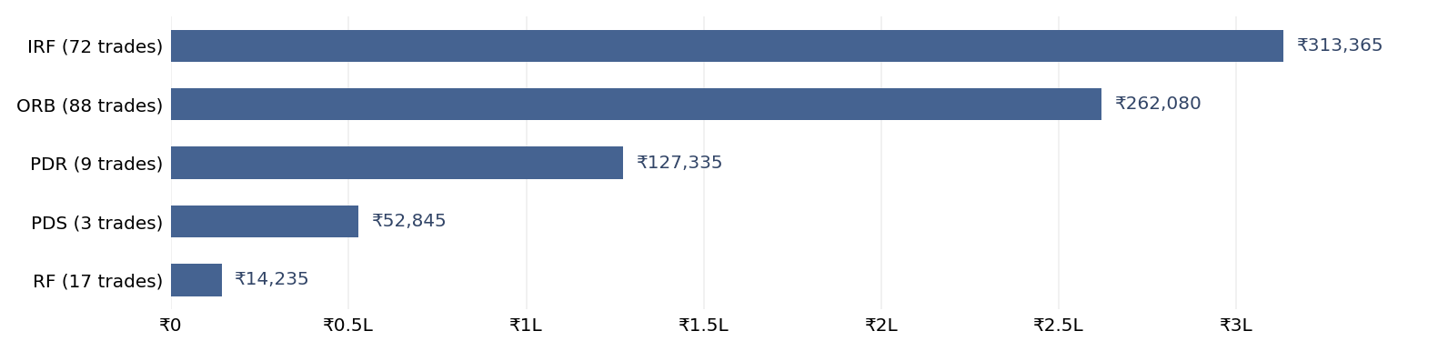
Figure 3. Net P&L by strategy, recreated from the reported strategy totals.
STRATEGY | TRADES | TARGET | SL | BE | WIN RATE  (EXCL. BE) | PROFIT  FACTOR | AVG /  TRADE | NET P&L | SHARE
IRF | 72 | 30 | 21 | 21 | 58.82% | 2.02 | ₹4,352 | ₹3,13,365 | 40.70%
ORB | 88 | 35 | 36 | 17 | 49.30% | 1.62 | ₹2,978 | ₹2,62,080 | 34.04%
PDR | 9 | 6 | 0 | 3 | 100.00% | — | ₹14,148 | ₹1,27,335 | 16.54%
PDS | 3 | 3 | 0 | 0 | 100.00% | — | ₹17,615 | ₹52,845 | 6.86%
RF | 17 | 6 | 8 | 3 | 42.86% | 1.14 | ₹837 | ₹14,235 | 1.85%
Total | 189 | 80 | 65 | 44 | 55.17% | 1.93 | ₹4,073 | ₹7,69,860 | 100.00%
PDR and PDS recorded no stop-losses during the period, so a profit factor cannot be calculated.

Sample Size & Reliability
ORB (88 trades) and IRF (72 trades) form 84.7% of the sample and provide the most reliable statistics; IRF was profitable in 10 of 12 months and ORB in 9 of 12. RF (17 trades) is a moderate sample with a profit factor of 1.14. PDR (9) and PDS (3) recorded no stop-losses, but their samples are too small to treat a 100% win rate as representative. For the strategy as a whole, the 95% confidence interval on the win rate (excl. BE) is approximately 47.1%–63.3% (n = 145); its lower bound remains above the 42.75% breakeven requirement.

Net P&L by Strategy and Month
MONTH | IRF | ORB | PDR | PDS | RF | TOTAL
Sep 2025 | ₹47,775 | –₹7,605 | ₹18,915 | — | –₹22,035 | ₹37,050
Oct 2025 | ₹25,545 | ₹14,625 | ₹37,830 | — | ₹16,965 | ₹94,965
Nov 2025 | ₹28,860 | ₹15,795 | ₹18,915 | — | ₹22,230 | ₹85,800
Dec 2025 | ₹195 | ₹19,890 | ₹18,915 | ₹18,915 | ₹16,965 | ₹74,880
Jan 2026 | ₹66,690 | ₹44,460 | — | — | ₹5,265 | ₹116,415
Feb 2026 | –₹17,355 | ₹61,425 | ₹16,965 | — | –₹58,500 | ₹2,535
Mar 2026 | ₹69,225 | –₹24,570 | — | — | — | ₹44,655
Apr 2026 | ₹15,210 | –₹7,605 | — | — | ₹16,965 | ₹24,570
May 2026 | ₹57,525 | ₹4,095 | ₹5,265 | — | — | ₹66,885
Jun 2026 | –₹31,590 | ₹54,990 | ₹10,530 | ₹16,965 | — | ₹50,895
Jul 2026 | ₹15,210 | ₹71,955 | — | ₹16,965 | ₹33,930 | ₹138,060
Aug 2026 | ₹36,075 | ₹14,625 | — | — | –₹17,550 | ₹33,150
Profitable months | 10 / 12 | 9 / 12 | 7 / 7 | 3 / 3 | 6 / 9 | 12 / 12
Total | ₹3,13,365 | ₹2,62,080 | ₹1,27,335 | ₹52,845 | ₹14,235 | ₹7,69,860
“—” indicates no trades in that strategy during the month. In 6 of 12 months, at least one strategy closed negative, but gains in the other strategies kept every month positive.

Transaction Cost Sensitivity
The results above are stated before brokerage, statutory charges and slippage. The table applies an illustrative all-in cost per trade (entry and both exits on all 6 lots) to show how much of the edge is retained after realistic friction.
COST PER TRADE | TOTAL COST (189 TRADES) | NET P&L | PROFIT FACTOR | AVG / TRADE | RETURN ON BASE
₹0 (as reported) | ₹0 | ₹7,69,860 | 1.93 | ₹4,073 | 769.86%
₹500 | ₹94,500 | ₹6,75,360 | 1.78 | ₹3,573 | 675.36%
₹1,000 | ₹1,89,000 | ₹5,80,860 | 1.65 | ₹3,073 | 580.86%
₹1,500 | ₹2,83,500 | ₹4,86,360 | 1.52 | ₹2,573 | 486.36%

Conclusion
Over September 2025 – August 2026, the NIFTY 6-lot execution model generated ₹7,69,860 across 189 trades, with a profit factor of 1.93, a win rate of 55.17% excluding BE trades, and a profit in every month. Drawdowns were contained and recovered quickly, the deepest being ₹68,055 in June 2026. IRF and ORB carry the strategy, PDR and PDS add high-quality but infrequent trades, and RF is the main candidate for refinement. The edge remains intact under every cost scenario tested, with a profit factor of 1.52 even at ₹1,500 per trade.

